**Application of GIS in Road Network Inventory**

By

Shamsher Alam (ID: 1104 07 062)

Shubhajit Saha (ID: 1104 07 060)

Under the guidance of Prof. Sujata Biswas

**INTRODUCTION**

**General**

The development of any country depends on the infrastructural facilities available therein. Good road network facilities plays major role here. The developed countries have good road infrastructure not because of the fact that they are wealthy; instead they become developed because of good road infrastructure. Realizing this fact an ambitious and biggest ever infrastructure development project in India (expected cost of $26 billion) named as Pradhan Mantri Gram Sadak Yojna (PMGSY) under ministry of Rural Development was conceptualized and launched on 25th December, 2000. to provide connectivity to unconnected rural habitations as part of a poverty eradication measure.

The main roads in India are under huge pressure and in great need of modernization in order to handle the increased requirements of the Indian economy. In addition to maintenance, the expansion of the network and widening of existing roads is becoming increasingly important. This would then enable the roads to handle increased traffic, and also allow for a corresponding increase in the average movement speed on India's roads.

**Condition of road network**

Almost 80% of passenger traffic and about 65% of freight movement is handled by this vast network.

In general, roads in India are primarily bitumen-based macadamized roads. However, a few of the National Highways have concrete roads too. In some locations, such as in Kanpur, British-built concrete roads are still in use. Concrete roads were less popular prior to 1990s because of low availability of cement then. However, with large supplies of cement in the country and the virtues of concrete roads, they are once again gaining popularity. Concrete roads are weather-proof and require lower maintenance compared to bituminous roads. Because bitumen is obtained mostly from imported crude oil, and due to other factors, concrete-based roads will prove to be more cost-effective in future. Apart from these, one also comes across unpaved dirt roads in the countryside, which is fast getting converted to paved roads.

**Indian Road Network**

**Class Length (km)**

Major district roads 470,000

National Highways/Expressways 66,754

Rural & other roads 2,650,000

State Highways 128,000

**Total (approx)** **3,314,754**

The National and State Highways form the economic backbone of the country. These have helped development along the route, and many towns have sprung up along major highways. State Highways and Major District Roads constitute the secondary system of road infrastructure of India.

By acting as the link between the rural and urban areas, the State Highways and Major District Roads contribute significantly to the development of the rural economy and industrial growth of the country. It is estimated that the secondary system carries about 40 per cent of the total road traffic and comprises about 20% of the total road length.

|  |  |  |  |  |  |  |
| --- | --- | --- | --- | --- | --- | --- |
| State-wise Road Network | | | | | | |
| State/UT | **National Highways (km)** | **State Highways (km)** | **Major District Roads (km)** | **Other District & Link Roads (km)** | **Total surfaced length (km) as on March 31, 2002** | **Total length (km) as on March 31, 2002** |
| Andaman & Nicobar | 300 |  |  |  | 1,180 | **1,180** |
| Andhra Pradesh | 4,472 |  |  |  | 1,19,857 | **1,96,172** |
| Arunachal Pradesh | 392 |  |  |  | 5,689 | **18,365** |
| Assam | 2,836 |  |  |  | 12,882 | **89,486** |
| Bihar | 3,642 |  |  |  | 32,858 | **76,065** |
| Chandigarh | 24 |  |  |  | 2,045 | **2,045** |
| Chhattisgarh | 2,184 |  |  |  | 24,476 | **35,372** |
| Dadra & Nagar Haveli |  |  |  |  | 580 | **580** |
| Daman & Diu |  |  |  |  | 324 | **414** |
| Delhi | 72 |  |  |  | 23,274 | **28,508** |
| Goa | 269 |  |  |  | 6,830 | **9,672** |
| Gujarat | 3,245 |  |  |  | 1,24,295 | **1,37,617** |
| Haryana | 1,512 |  |  |  | 26,311 | **28,203** |
| Himachal Pradesh | 1,208 | 2,160 | 2,240 |  | 16,754 | **29,617** |
| Jammu & Kashmir | 1,245 |  |  |  | 9,943 | **23,429** |
| Jharkhand | 1,805 |  |  |  | 2,840 | **11,486** |
| Karnataka | 3,843 |  |  |  | 1,04,241 | **1,52,599** |
| Kerala | 1,457 | 4,006 | 23,702 |  | 50,164 | **1,50,851** |
| Lakshadweep |  |  |  |  | 150 | **150** |
| Madhya Pradesh | 4,670 |  |  |  | 78,191 | **1,60,968** |
| Maharashtra | 4,176 | 33,705 |  |  | 2,09,559 | **2,67,452** |
| Manipur | 959 |  |  |  | 3,863 | **11,434** |
| Meghalaya | 810 |  |  |  | 6,560 | **9,565** |
| Mizoram | 927 |  |  |  | 2,877 | **5,075** |
| Nagaland | 494 |  |  |  | 6,451 | **21,021** |
| Orissa | 3,704 |  |  |  | 52,245 | **2,37,034** |
| Puducherry | 53 |  |  |  | 2,115 | **2,571** |
| Punjab | 1,557 | 2,166 | 1,799 | 34,997 | 52,747 | **61,530** |
| Rajasthan | 5,585 |  |  |  | 82,456 | **1,32,482** |
| Sikkim | 62 |  |  |  | 1,546 | **2,019** |
| Tamil Nadu | 4,462 | 7,163 | 7,362 | 40,963 | 1,54,958 | **1,91,947** |
| Tripura | 400 |  |  |  | 4,393 | **16,296** |
| Uttarakhand | 1,991 |  |  |  | 10,730 | **33,547** |
| Uttar Pradesh | 5,874 |  |  |  | 1,66,659 | **2,48,481** |
| West Bengal | 2,524 |  |  |  | 49,517 | **92,023** |
| Total | **66,754** |  |  |  |  |  |

**Pradhan Mantri Gram Sadak Yojana (PMGSY)**

**Objective**

1 ) The primary objective of the PMGSY is to provide Connectivity, by way of an All-weather Road (with necessary culverts and cross-drainage structures, which is operable throughout the year), to the eligible unconnected Habitations in the rural areas, in such a way that all Unconnected Habitations with a population of 1000 persons and above are covered in three years (2000-2003) and all Unconnected Habitations with a population of 500 persons and above by the end of the Tenth Plan Period (2007). In respect of the Hill States (North-East, Sikkim, Himachal Pradesh, Jammu & Kashmir, Uttaranchal) and the Desert Areas (as identified in the Desert Development Programme) as well as the Tribal (Schedule V) areas, the objective would be to connect Habitations with a population of 250 persons and above.

2 )The PMGSY will permit the Upgradation (to prescribed standards) of the existing roads in those Districts where all the eligible Habitations of the designated population size (refer Para 2.1 above) have been provided all-weather road connectivity. However, it must be noted that Upgradation is not central to the Programme and cannot exceed 20% of the State’s allocation as long as eligible Unconnected Habitations in the State still exist. In Upgradation works, priority should be given to Through Routes of the Rural Core Network, which carry more traffic

**Guiding princicles**

1. The spirit and the objective of the Pradhan Mantri Gram Sadak Yojana (PMGSY) is to provide good all-weather road connectivity to unconnected Habitations. A habitation which was earlier provided all-weather connectivity would not be eligible even if the present condition of the road is bad.
2. The unit for this Programme is a Habitation and not a Revenue village or a Panchayat. A **Habitation** is a cluster of population, living in an area, the location of which does not change over time. Desam, Dhanis, Tolas, Majras, Hamlets etc. are commonly used terminology to describe the Habitations.
3. An **Unconnected Habitation** is one with a population of designated size (refer to Para 2.1 above) located at a distance of at least 500 metres or more (1.5 km of path distance in case of Hills) from an All-weather road or a connected Habitation.
4. Para 2.1 above refers to Population size of Habitations. The population, as recorded in the Census 2001, shall be the basis for determining the population size of the Habitation. The population of all Habitations within a radius of 500 metres (1.5 km. of path distance in case of Hills) may be clubbed together for the purpose of determining the population size. This **cluster approach** would enable provision of connectivity to a larger number of Habitations, particularly in the Hill / mountainous areas.
5. The eligible Unconnected Habitations are to be connected to nearby Habitations already connected by an All-weather road or to another existing All-weather road so that services (educational, health, marketing facilities etc.), which are not available in the unconnected Habitation, become available to the residents.
6. A **Core Network** is that minimal Network of roads (routes)that is essential to provide Basic access to essential social and economic services to all eligible habitations in the selected areas through at least a single all-weather road connectivity.
7. A Core Network comprises of **Through Routes** and **Link Routes**. Through routes are the ones which collect traffic from several link roads or a long chain of Habitations and lead it to Marketing centres either directly or through the higher category roads i.e., the District Roads or the State or National Highway. **Link Routes** are the roads connecting a single Habitation or a group of Habitations to Through Routes or District Roads leading to Market Centres. Link routes generally have dead ends terminating on a Habitation, while Through Routes arise from the confluence of two or more Link Routes and emerge on to a major Road or to a Market Centre.
8. It should be ensured that each road work that is taken up under the PMGSY is part of the Core Network. While keeping the objective of Connectivity in view, preference should be given to those roads which also incidentally serve other Habitations. In other words, without compromising the basic objective (covering 1000+ Habitations first and 500+ Habitations next and 250+ Habitations where eligible, last), preference should be given to those roads which serve a larger population. For this purpose, while Habitations within a distance of 500 metres from the road is considered as connected in case of plain areas, this distance should be 1.5 km (of path length) in respect of Hills.
9. The PMGSY shall cover only the rural areas. Urban roads are excluded from the purview of this Programme. Even in the rural areas, PMGSY covers only the **Rural Roads** i.e., Roads that were formerly classified as ‘Other District Roads’ (ODR) and ‘Village Roads’ (VR). **Other District Roads** (ODR) are roads serving rural areas of production and providing them with outlet to market centres, taluka (tehsil) headquarters, Block headquarters or other main roads. **Village Roads** (VR) are roads connecting villages / Habitation or groups of Habitation with each other and to the nearest road of a higher category. Major District Roads, State Highways and National Highways cannot be covered under the PMGSY, even if they happen to be in rural areas. This applies to New Connectivity roads as well as Upgradation works.
10. The PMGSY envisages only single road Connectivity to be provided. If a Habitation is already connected by way of an All-weather road, then no new work can be taken up under the PMGSY for that habitation.
11. Provision of connectivity to unconnected Habitations would be termed as **New Connectivity**. Since the purpose of PMGSY inter alia is to provide farm to market access, new connectivity may involve ‘new construction’ where the link to the habitation is missing and additionally, if required, ‘upgradation’ where an intermediate link in its present condition cannot function as an all-weather road (see Para 3.12 below)
12. **Upgradation**, when permitted (refer Para 2.2 and 3.11 above) would typically involve building the base and surface courses of an existing road to desired technical specifications and / or improving the geometrics of the road, as required in accordance with traffic condition. (see also Para 3.14 below)
13. The primary focus of the PMGSY is to provide All-weather road connectivity to the eligible unconnected Habitations. An **All-weather road** is one which is negotiable in all seasons of the year. This implies that the road-bed is drained effectively (by adequate cross-drainage structures such as culverts, minor bridges and causeways), but this does not necessarily imply that it should be paved or surfaced or black-topped. Interruptions to traffic as per permitted frequency and duration may be allowed.
14. There may be roads which are **Fair-weather roads**. In other words, they are fordable only during the dry season, because of lack of Cross Drainage (CD) works. Conversion of such roads to All-weather roads through provision of CD works would be treated as upgradation. It must be noted that on all the road works of the PMGSY, provision of necessary CD works is considered an essential element
15. PMGSY does not permit repairs to Black-topped or Cement Roads, even if the surface condition is bad.
16. The Rural Roads constructed under the Pradhan Mantri Gram Sadak Yojana will be in accordance with the provision of the Indian Roads Congress (IRC) as given in the Rural Roads Manual (IRC:SP20:2002). In case of Hill Roads, for matters not covered by the Rural Roads Manual, provisions of Hills Roads Manual (IRC:SP:48) may apply.

**\*Attempt made to study the road network of arambagh block using gis**

**Geographic information systems (GIS)**

Geographic information systems (GIS) or geospatial information systems is a set of tools that captures, stores, analyzes, manages, and presents data that are linked to location(s). In the simplest terms, GIS is the merging of cartography, statistical analysis, and database technology. GIS may be used in archaeology, geography, cartography, remote sensing, land surveying, public utility management, natural resource management, precision agriculture, photogrammetry, urban planning, emergency management, navigation, aerial video, and localized search engines.

As GIS can be thought of as a system, it digitally creates and "manipulates" spatial areas that may be jurisdictional, purpose or application oriented for which a specific GIS is developed. Hence, a GIS developed for an application, jurisdiction, enterprise, or purpose may not be necessarily interoperable or compatible with a GIS that has been developed for some other application, jurisdiction, enterprise, or purpose. What goes beyond a GIS is a spatial data infrastructure (SDI), a concept that has no such restrictive boundaries.

Therefore, in a general sense, the term describes any information system that integrates, stores, edits, analyzes, shares, and displays geographic information for informing decision making. GIS applications are tools that allow users to create interactive queries (user-created searches), analyze spatial information, edit data, maps, and present the results of all these operations.[1] Geographic information science is the science underlying the geographic concepts, applications and systems.[2] GIS can be studied in degree and certificate programs at many universities.

**Raster graphics**

In computer graphics, a raster graphics image or bitmap is a data structure representing a generally rectangular grid of pixels, or points of color, viewable via a monitor, paper, or other display medium. Raster images are stored in image files with varying formats (see Comparison of graphics file formats).

A bitmap corresponds bit-for-bit with an image displayed on a screen, generally in the same format used for storage in the display's video memory, or maybe as a device-independent bitmap. A bitmap is technically characterized by the width and height of the image in pixels and by the number of bits per pixel (a color depth, which determines the number of colors it can represent).

The printing and prepress industries know raster graphics as contones (from "continuous tones") and refer to vector graphics as "line work".

**Vector graphics**

Vector graphics is the use of geometrical primitives such as points, lines, curves, and shapes or polygon(s), which are all based on mathematical equations, to represent images in computer graphics.

Vector graphics formats are complementary to raster graphics, which is the representation of images as an array of pixels, as it is typically used for the representation of photographic images.[1] There are instances when working with vector tools and formats is the best practice, and instances when working with raster tools and formats is the best practice. There are times when both formats come together. An understanding of the advantages and limitations of each technology and the relationship between them is most likely to result in efficient and effective use of tools.

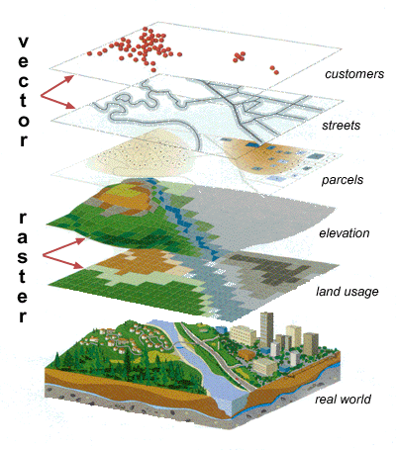

**OBJECTIVE**

1. To study the existing core network from the district rural plan (DRRP) map preprared by the authority.
2. To develop rural road network inventory in block level.

**PRESENT STUDY**

Rural Road Inventory

PMGSY Map

Habitation level

Road Reference

Road Geometric Details

Road pavement condition

Terrain & soil type & traffic

CD

* Serial no.
* Name of the road
* Road code
* Length
* Carriage Width
* Surface type
* CBR
* Total traffic per day
* Commercial vechicle perday
* Total length
* Width

**Data collection**

|  |  |  |  |  |  |  |  |  |  |  |
| --- | --- | --- | --- | --- | --- | --- | --- | --- | --- | --- |
| **Sr.No.** | [Name of District](https://www.online.omms.nic.in/government/ims/online/datasheet/SanctionedRoad4STA.asp?district=8&state=WB&year=0&packageId=0&stream=0&roadStatus=0&Batch=0&OrderBy=Desc&sortby=4) | **Name of Block** | **Road Name** | **Pavement** | **Design** | | | | **Traffic Intensity** | **CBR Value** |
| **Length (in Kms)** | **Carriage Way Width** | **Proposed Surface** | **Curve Type** | **Related Road in Core Network** |
| **1** | **2** | **3** | **6** | **11** | **31** | **32** | **33** | **34** | **36** | **37** |
| 3 | Hooghly | Arambag | Duttapur - Monirampur upto Acharjapara | 5.55 | 3.75 | Sealed Surface | B | T05 | 2008,93,24 | 4,5,3.61 |
| 4 | Hooghly | Arambag | Bais Mile - Batanal | 10.18 | 3.75 | Unsealed | B | T01 | 2004,105,49 | 4.5,9.5,3.12 |
| 5 | Hooghly | Arambag | Harinkhola - Purba Keshabpur | 5.73 | 3.75 | Unsealed | B | T01 | ##### | 3.5,5.7,3.53 |
| 6 | Hooghly | Arambag | Charmile - Dakshinnarayanpur | 12.64 | 3.75 | Sealed Surface | B | T11 | 2007,305,18 | 11.349,12.258,3.21 |
| 7 | Hooghly | Arambag | GoghatMetalRoad - Bijalkona | 17.92 | 3.75 | Sealed Surface | B | T14 | 2007,233,15 | 16.395,17.915,3.98 |

**Map Data**

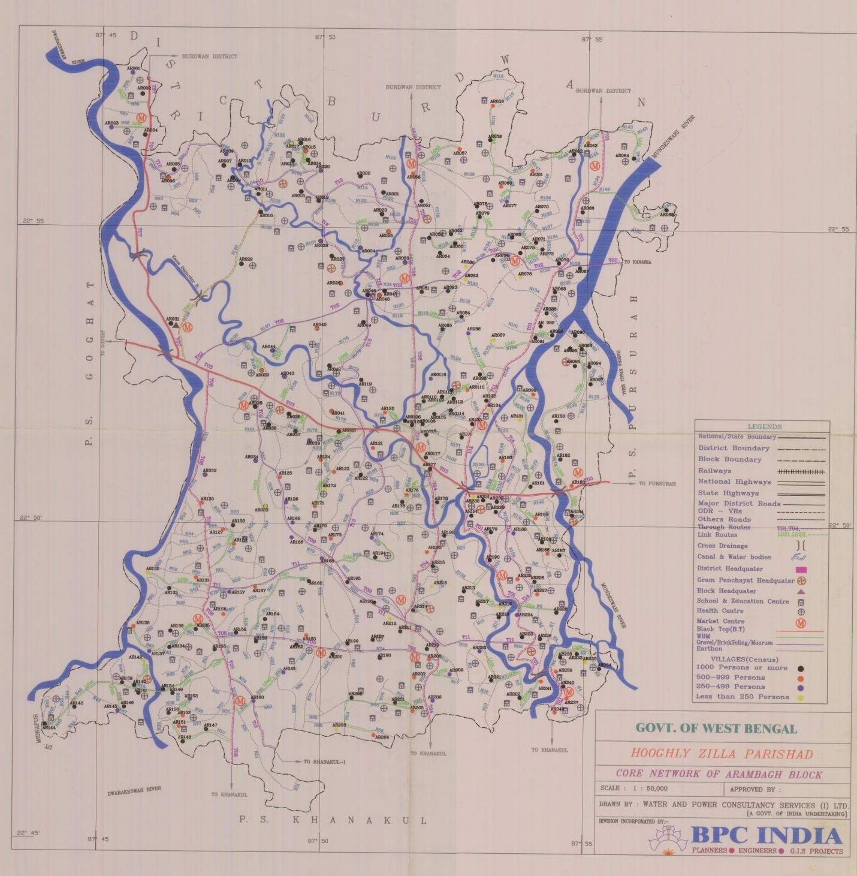

Map of Arambagh Block (Scale 1:50,000)